REPORT
Student Name: Phan Nguyễn Thảo Như
Student: 524V0007
Class: 24K50201

Introduction
The primary objective of this lab is to achieve the following technical milestones:
- Architectural Implementation: To construct a robust Student Management web application by strictly adhering to the Model-View-Controller (MVC) design pattern and Razor Pages, ensuring a clean separation of concerns.
- Data Persistence & Integration: To leverage Entity Framework Database First for seamless Object-Relational Mapping (ORM), facilitating efficient communication and data manipulation with the SQL Server backend.
- Core Functionality Deployment: To implement comprehensive CRUD (Create, Read, Update, Delete) operations, establishing a functional interface for data management.
- Feature Optimization: To enhance application usability and data integrity through the integration of advanced features, including Server-side Validation, dynamic Search Filters, and efficient data display.

Exercises
- Implementation Steps:
  - Exercise 1: Integrated the SQL Server database into the project via Entity Framework Core. Leveraged the Scaffolding feature to automatically generate the underlying source code for the Index, Create, Edit, and Delete interfaces, ensuring a consistent CRUD workflow within a page-based architecture.

  - Exercise 2: Developed a parallel version using the MVC pattern. Modified the Model classes by incorporating the System.ComponentModel.DataAnnotations namespace. Implemented various attributes such as [Required], [StringLength], and [EmailAddress] to enforce strict data integrity and control user input at the model level

- I have many problems in this lab:
  - Scaffolding Error: Failed to install or resolve the CodeGeneration.Design package due to environment conflicts. I initialized the scaffolding engine by creating an Empty Controller/Page as a "template" or manually configuring the DbContext before generating the final EF entities.
  - Configuration Error: The system initially failed to recognize the DbContext due to incorrectly ordered configurations. I ensured the Database registration in Program.cs (or Web.config for legacy environments) followed the strict order of operations required by the framework to ensure the Entity Framework configuration was parsed correctly.
  - Name Collision: Encountered a CS0118 error where the Namespace was confused with the Model type. Resolved this by refactoring the folder structure to use plural naming conventions (e.g., Students) to distinguish the namespace from the class type.

-exc1:
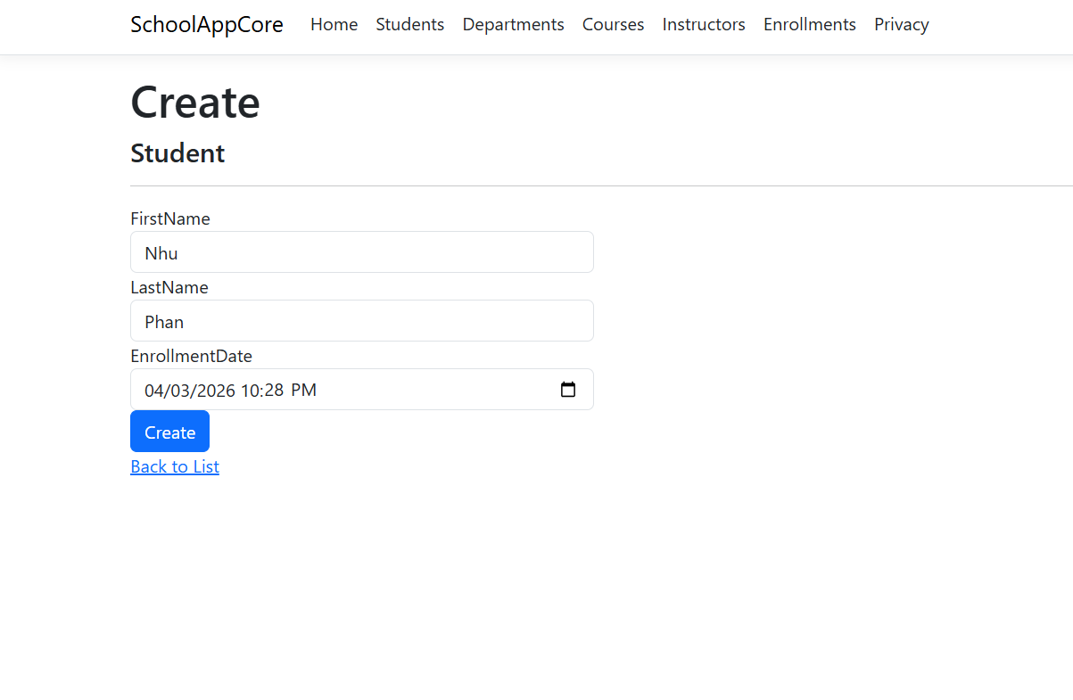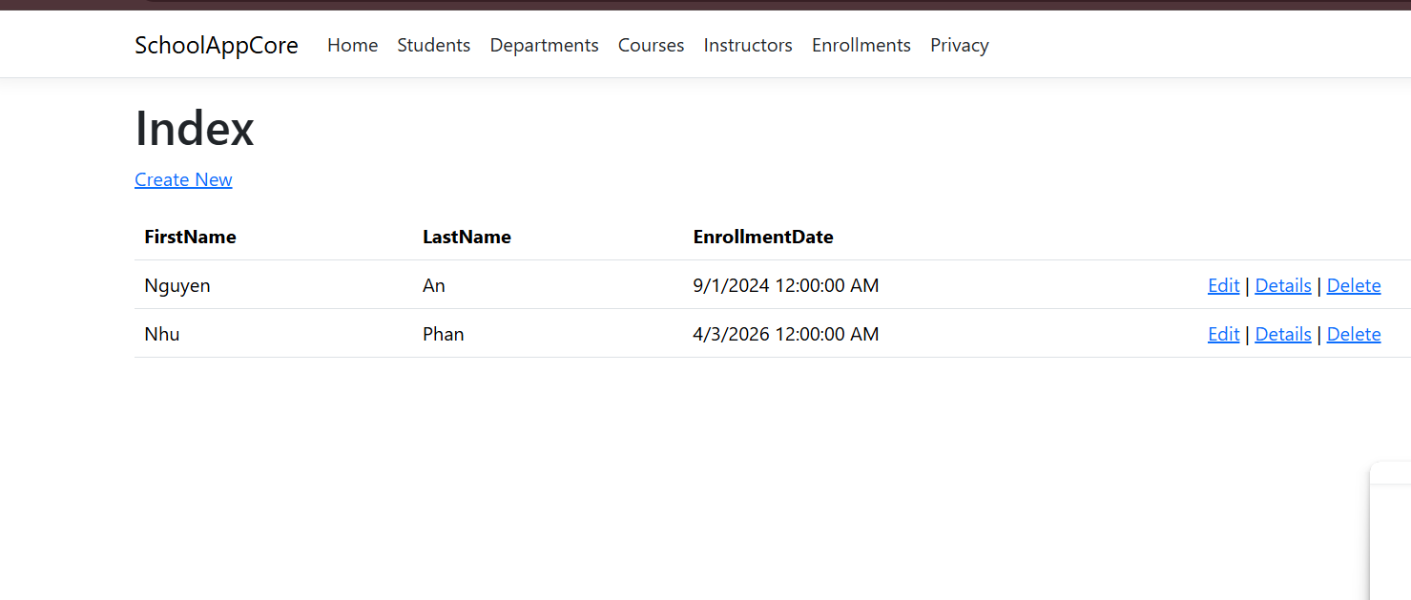
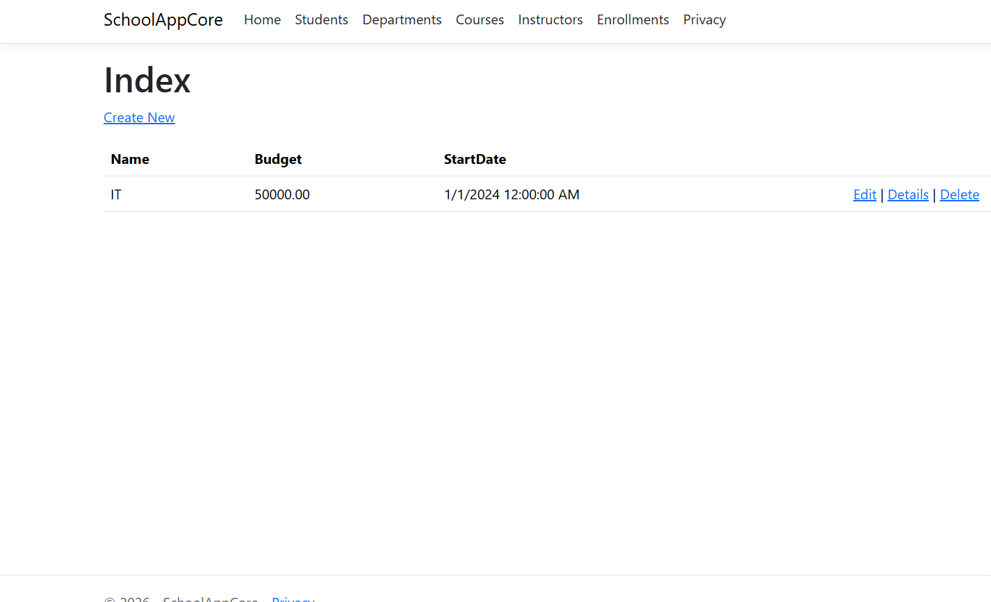
-exc2:
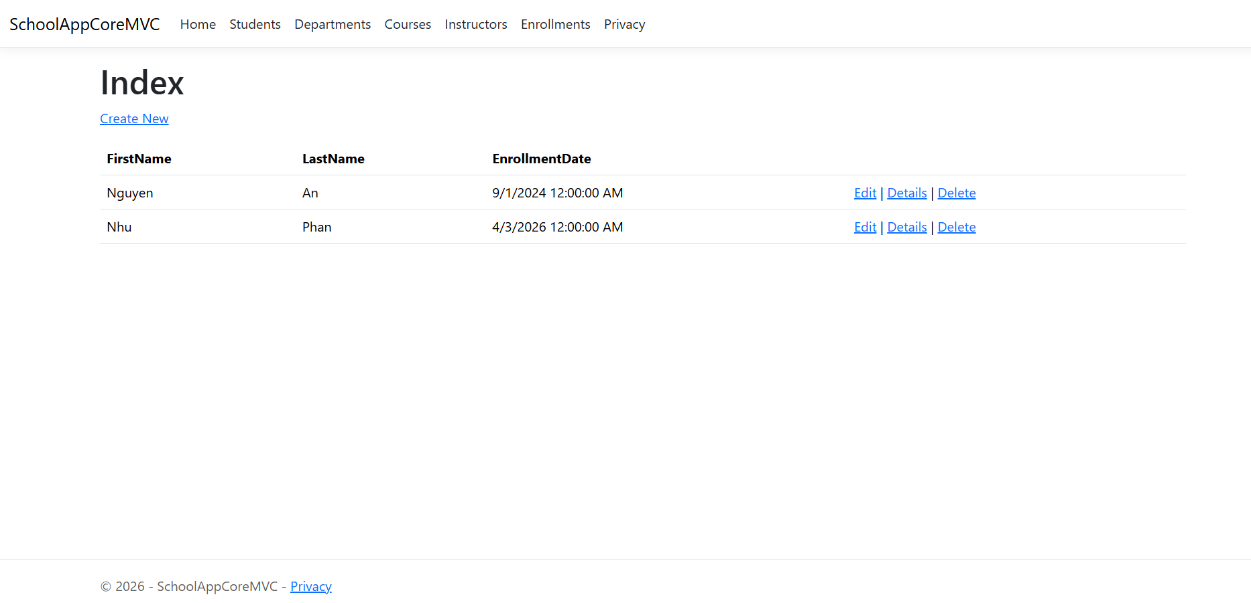

-Link GitHub: https://github.com/Babicute-29/SchoolAppCore ,https://github.com/Babicute-29/SchoolAppCoreMVC, https://github.com/Babicute-29/SQLLAB07

